# GameObject Brush v 3.1

By Kellojo

Contributed to by:

* [Dylan Valentine („dval“, added all new features in v3.1)](https://github.com/dval)

## Documentation

This documentation contains a detailed overview over the functionality of the tool.

### Quickstart Guide

To start using GameObject Brush is really very easy. The following steps will guide you towards using it in your projects.

1. Navigate to **„Tools“ >> „GameObject Brush“** and open the GameObject Brush Window.

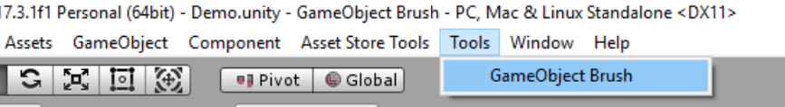

1. The following window should appear:

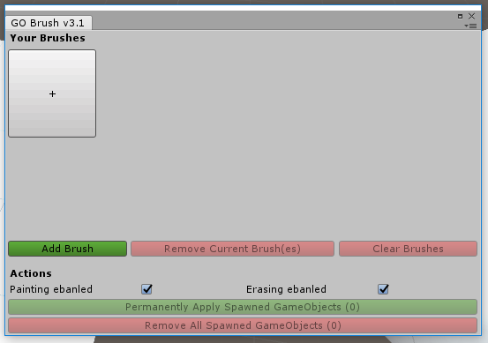

This is the GameObject Brush main window, in which you can perform various actions to manipulate the way this addon works.

1. To get started click the big **„+“ button** in the top left of the window which is going to open another small popup window:

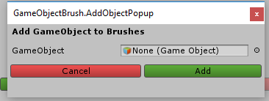

In this window you can **select a gameobject** that should be added to you brush selection. To add a GameObject, just select a gameobject or prefab from your project and click the **“Add” button.**

1. The newly added brush should now appear in your brush selection.

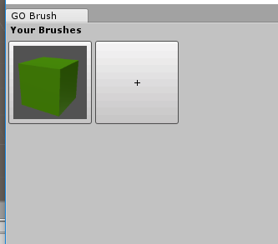

1. By **clicking this** newly **created brush** you can **modify the settings** on it:

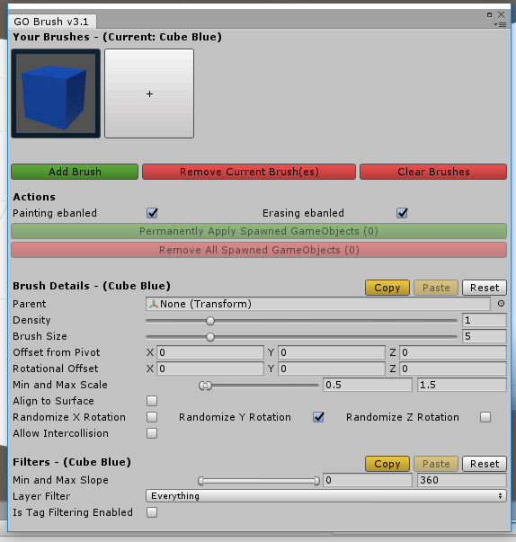

1. To **start painting** all you must do now, is to go into your **scene view and start hovering over objects that** **have a collider on them** and press **left click to paint** new objects and **right click to erase** them.
2. To start **painting with multiple brushes**, just **hold <<CTRL>> while clicking** **on one more brush to select it** and you can start painting.

### Button and Settings Documentation

In the following screenshot you can see all settings and actions that can be manipulated and performed within GameObject Brush.

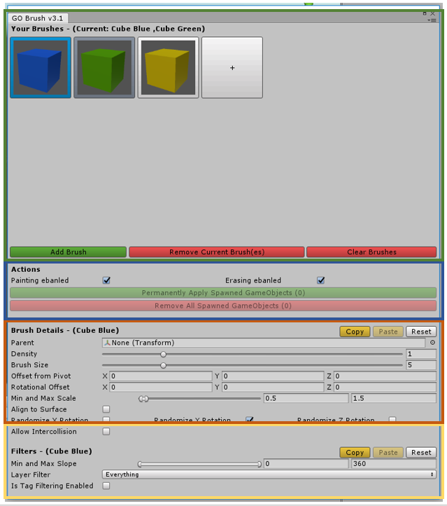

The window is split up into these three sections:

* The brush selection
* The actions section
* The brush details section
* The filters section

#### The brush selection

In the brush selection you can add, remove and clear all brushes and choose the current brush. As of version 3.0 it is now possible to **paint with multiple brushes at a time**. To do this all you have to do is to hold **<<CTRL>>** while **clicking** on one or more of your brushes to select them. This is going to add the to the selection (indicated by the light and dark blue color). A light blue color is indicating that the brush is in your active selection but can not be edited in the below sections. A dark blue color is indicating that the brush is currently selected and can be edited in the below sections.

#### The actions section

In the actions section you can Permanently apply the gameobjects that have been spawned with the tool, so they can not be erased by accident anymore or you can remove all spawned objects (with the tool) from the scene that have not been applied before. Also, you can enable and disable the erasing and painting functionality.

#### The brush details section

The brush details section has many settings that can be modified. Also, it is possible to copy, paste and reset these settings through the three buttons next to the heading.

##### Parent:

This property allows for easy organizing of the instantiated objects to make sure your hierarchy stays clean.

##### Density:

Changes the density of the brush, i.e. how many gameobjects are spawned inside the radius of the brush.

##### Brush Size:

The radius of the brush.

##### Offset from Pivot:

Changes the offset of the spawned gameobject from the calculated position. This allows you to correct the position of the spawned objects, if you find they are floating for example due to a not that correct pivot on the gameobject/prefab.

##### Rotational Offset:

Changes the rotational offset that is applied to the prefab/gameobject when spawning it. This allows you to current the rotation of the spawned objects.

##### Min and Max Scale:

The min and max range of the spawned gameobject. If they are not the same value a random value in between the min and max is going to be picked.

##### Align to Surface:

This option allows you to align the instantiated gameobjects to the surface you are painting on.

##### Randomize Rotation:

Allows you to randomize the rotation of the object on the x, y and z axis. The rotation is randomized between 0 and 360 degrees.

##### Allow Intercollision:

Should the spawned objects be considered for the spawning of new objects? If so, newly spawned objects can be placed on top of previously (not yet applied) objects.

#### The filters section

The filters section allows the filtering by slope, layer and tag. Also, it is possible to copy, paste and reset these settings through the three buttons next to the heading.

##### Min and Max Slope:

The range of slope that is required for an object to be placed. If the slope is not in that range, no object is going to be placed.

##### Layer Filter:

The Layers that painting on is enabled. When trying to paint on a layer that is not in the layer mask no objects are going to be placed.

##### Tag Filtering:

Limits the painting to objects that have a specific tag on them.